International Journal of Computer Trends and Technology Volume 72 Issue 9, 18-23, September 2024
ISSN: 2231–2803 / https://doi.org/10.14445/22312803/IJCTT-V72I9P104 © 2024 Seventh Sense Research Group®

Original Article

SOLID Design Principles in Software Engineering
Naveen Chikkanayakanahalli Ramachandrappa Lead Mobile Dev & Quality Engineer, Texas, USA. Corresponding Author : accessnaveen@gmail.com
Received: 17 July 2024 Revised: 18 August 2024 Accepted: 09 September 2024 Published: 28 September 2024

Abstract - In contemporary software development, ensuring clarity, flexibility, and maintainability remains a persistent challenge, particularly as systems grow in complexity. While SOLID principles offer a robust framework to address these issues, many developers struggle with understanding and applying these guidelines effectively in real-world scenarios. Developed by Robert C. Martin, these principles—Single Responsibility Principle, Open/Closed Principle, Liskov Substitution Principle, Interface Segregation Principle, and Dependency Inversion Principle—are fundamental to object-oriented programming, especially in languages such as C#. This document addresses the research gap by offering a comprehensive exploration of each SOLID principle, utilizing practical C# examples to elucidate its application. The goal is to provide developers with actionable insights into leveraging these principles to overcome common challenges.

Keywords - Cohesion, Decoupling, Extensibility, Modularity, Substitutability.

Introduction
The domain of software engineering is rapidly advancing, with increasing complexity posing new challenges. To address these challenges, design principles that foster maintainability and scalability have gained prominence. Among these, the SOLID principles—an acronym for five essential design guidelines—are fundamental to contemporary object-oriented design. Introduced by Robert C. Martin, also known as "Uncle Bob," SOLID principles offer a structured approach to creating code that is both comprehensible and adaptable.

Each principle targets a distinct aspect of software design, guiding practices that minimize dependencies and enhance code cohesion. The Single Responsibility Principle (SRP) advocates that a class should have only one reason to change, thus improving maintainability and reducing errors.

The Open/Closed Principle (OCP) suggests that classes should be extendable without modifying existing code, encouraging the use of interfaces and abstract classes. The Liskov Substitution Principle (LSP) ensures that subclasses can replace their parent classes without altering the functionality of the program.

The Interface Segregation Principle (ISP) promotes the use of multiple, smaller interfaces over a single, large one. Lastly, the Dependency Inversion Principle (DIP) emphasizes relying on abstractions rather than concrete classes. This paper explores each of these principles in detail, using C# examples to demonstrate their practical application. It also addresses common challenges and misconceptions, offering strategies to
navigate them effectively. The objective is to provide a comprehensive understanding of SOLID principles and their practical implementation in software development.

Single Responsibility Principle (SRP)
The Single Responsibility Principle asserts that a class should be designed to fulfill a single function or duty. This principle is vital as it guarantees that each class remains dedicated to a specific task, which in turn simplifies its understanding, maintenance, and potential for expansion.

Importance of SRP
The Single Responsibility Principle (SRP) simplifies code by ensuring that each class is designed with a distinct and specific function. This focused approach enhances the code's readability and maintainability.

When classes follow SRP, they become more straightforward to refactor, test, and extend. By confining each class to a single responsibility, modifications are less likely to affect other parts of the system, thereby minimizing the risk of introducing errors.

The Problem with Violating SRP
Consider a user class that handles user data and manages user authentication:

In this example, the User class has two responsibilities: managing user data and handling user authentication. If the authentication logic changes, the User class will need to be modified, violating the SRP.


This is an open access article under the CC BY-NC-ND license (http://creativecommons.org/licenses/by-nc-nd/4.0/)

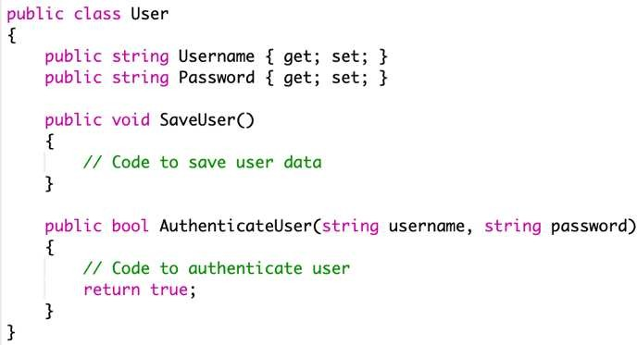

Fig. 1 The problem with violating SRP

Applying SRP
To adhere to SRP, we should separate the responsibilities into different classes:
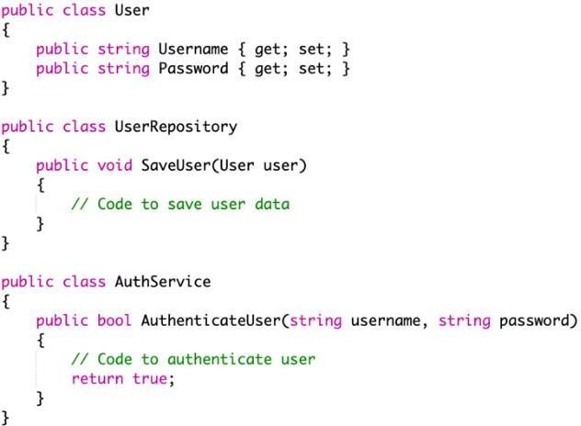
Fig. 2 Applying SRP

Now, the User class is responsible only for holding user data, UserRepository handles data persistence, and AuthService manages authentication. Each class has a single responsibility, making the code more modular and easier to maintain [1].

Open/Closed Principle (OCP)
The Open/Closed Principle asserts that software components, such as classes, modules, or functions, should be designed to allow for extension without requiring changes to their existing code. This principle advocates for the enhancement of a module’s functionality through new code rather than modifications to the existing codebase.

Importance of OCP
OCP is crucial for maintaining the stability of the software as it evolves. By adhering to OCP, developers can add new functionality to existing code without altering the existing codebase, minimizing the risk of introducing new bugs.

The Problem with Violating OCP
Imagine we have a DiscountCalculator class that calculates discounts based on different customer types:

Fig. 3 The problem with violating OCP


If we need to add a new customer type, we must modify the DiscountCalculator class, violating the OCP.

Applying OCP
To adhere to OCP, we can use polymorphism to extend the behavior without modifying existing code:

Fig. 4 Applying OCP

Now, adding a new customer type requires creating a new class that extends the customer without modifying the discount calculator [2].

Liskov Substitution Principle (LSP)
The Liskov Substitution Principle holds that instances of a parent class should be replaceable with instances of a derived class without altering the correctness of the program. This principle is crucial for maintaining a well-structured class hierarchy, ensuring that subclasses can seamlessly substitute for their parent classes without introducing errors or inconsistencies.

Importance of LSP
LSP ensures that a subclass can stand in for its superclass, making the code more predictable and reliable. Violating LSP can lead to unexpected behavior in the software, particularly when subclasses override methods in ways that are not consistent with the superclass's intended behavior. LSP is crucial for the correct use of polymorphism and inheritance. It ensures that a derived class can be substituted for its base class without altering the behavior of the program. Adhering to LSP results in more reliable and maintainable code, particularly in large systems where polymorphism is heavily used.

The Problem with Violating LSP
Consider the following example where a Penguin class subclasses a Bird class:

Here, substituting a Penguin object for a Bird object would cause the program to break, violating the LSP.
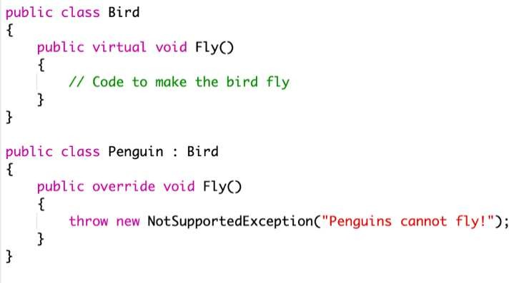
Fig. 5 The problem with violating LSP

Applying LSP
To adhere to LSP, the design should be refactored so that subclasses can be substituted for their base classes without any issues:

Fig. 6 Applying LSP
In this design, Penguin does not implement the IFlyingBird interface, so it cannot be substituted in a context where flying is required, thus adhering to LSP [3].

Interface Segregation Principle (ISP)
The Interface Segregation Principle advises that no client should be forced to depend on methods it does not use. This principle promotes the creation of smaller, more specific interfaces rather than large, general-purpose ones.

Importance of ISP
ISP promotes decoupling by ensuring that classes depend only on the interfaces that are relevant to them. This reduces the impact of changes and makes the codebase more flexible. Adhering to ISP can lead to more modular and testable code. By following ISP, we create more focused and easier-to- maintain interfaces. This reduces the risk of breaking changes when interfaces evolve and enhances the modularity of the codebase. ISP also simplifies testing, as each class can be tested in isolation from the methods it does not use.

The Problem with Violating ISP
Consider an interface IMachine that is implemented by both a printer and a scanner:
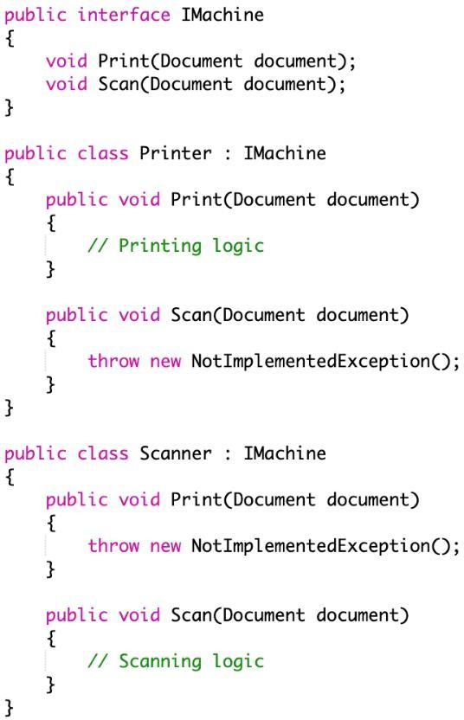
Fig. 7 The problem with violating ISP

In this example, both the Printer and Scanner are forced to implement methods they do not use, which violates ISP.

Applying ISP
To adhere to ISP, we can break down the IMachine interface into smaller, more specific interfaces:
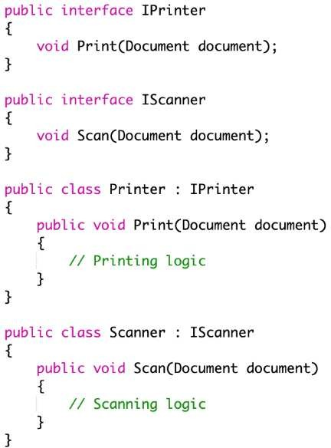
Fig. 8 Applying ISP

Now, each class only implements the methods it uses, adhering to ISP [4].

Dependency Inversion Principle (DIP)
The Dependency Inversion Principle dictates that high- level components should not be reliant on low-level components; instead, both should depend on abstractions. Furthermore, it emphasizes that abstractions should not rely on specific details, but rather, those details should depend on the abstractions.

Importance of DIP
The Dependency Inversion Principle (DIP) advocates for the separation of software components by promoting reliance on abstractions rather than concrete implementations. This approach significantly enhances the modularity of the code, making development, testing, and maintenance much more manageable. By decoupling high-level and low-level modules through abstractions, systems become more flexible and resilient to changes, allowing for easy updates and substitutions with minimal disruption to the overall architecture. Embracing DIP helps in crafting a robust and adaptable software structure that can accommodate evolving requirements and technological advancements, ultimately ensuring better scalability and longevity for the application.

The Problem with Violating DIP
Consider a UserService class that directly depends on concrete EmailService: In this example, the UserService class is tightly coupled to the EmailService class. If the way emails are sent changes (e.g., switching to a different email provider), the UserService class must be modified, which violates the Dependency Inversion Principle (DIP).

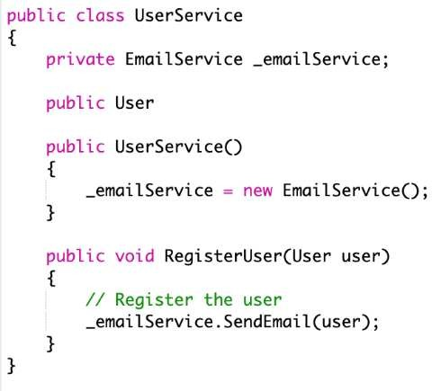
Fig. 9 The problem with violating DIP

Applying DIP
To adhere to DIP, we can introduce an abstraction (e.g., an interface) that the UserService depends on and then implement that interface in the EmailService class. This decouples the high-level module from the low-level module. In the following refactored example, the UserService class now depends on the IEmailService interface rather than a concrete implementation. This design allows for easier changes and testing, as different implementations of IEmailService can be injected without modifying the UserService class [5].
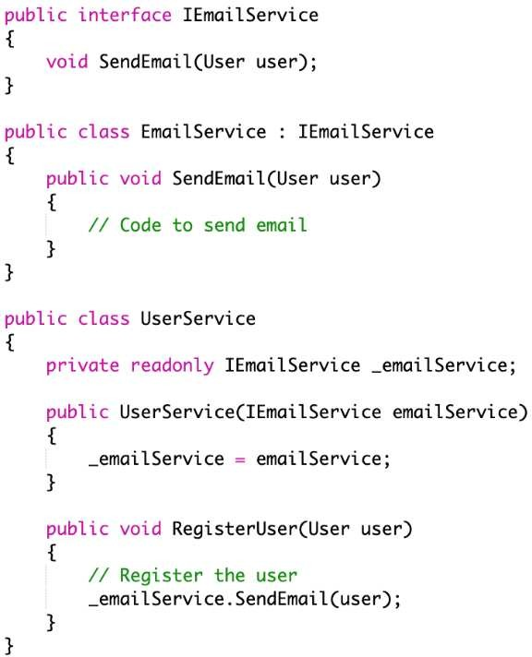
Fig. 10 Applying DIP

Case Study: Applying SOLID Principles in a Real world Scenario
To demonstrate the application of SOLID principles in a real-world scenario, consider a simple e-commerce system. The system requires several services, such as order processing,

inventory management, and payment processing. By applying SOLID principles, we can design the system to be flexible, scalable, and maintainable.

Single Responsibility Principle
Each service in the e-commerce system should have a single responsibility. For example, the OrderService should only handle order-related operations, while InventoryService should manage inventory. This clear separation of responsibilities makes each service easier to maintain.
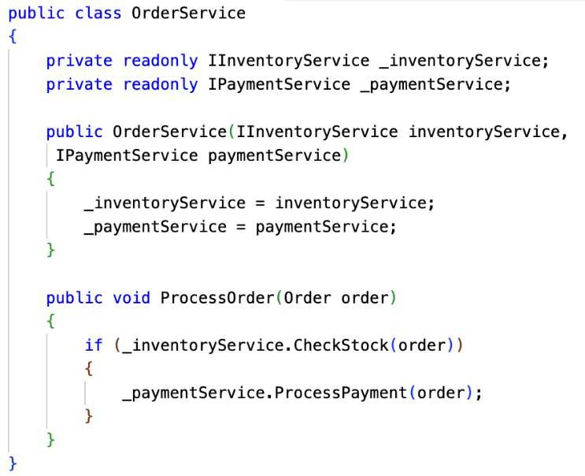
Fig. 11 Single responsibility principle

Open/Closed Principle
If we need to introduce a new payment method (e.g., mobile payments), we should not modify the existing PaymentService. Instead, we can create a new class that implements the IPaymentService interface. The OrderService can now accept any implementation of IPaymentService without requiring changes to its code.
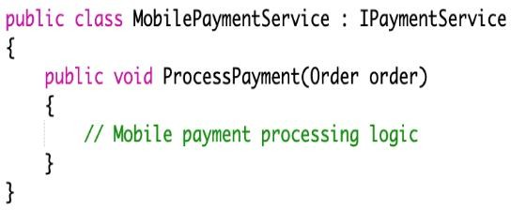
Fig. 12 Open/Closed principle

Liskov Substitution Principle
If a new DiscountService is introduced, it should adhere to the LSP by ensuring that any subclass of a DiscountService can replace it without altering the behavior of the OrderService.


Fig. 13 Liskov substitution principle

The OrderService can utilize the DiscountService without needing to know the specifics of the discount applied, ensuring that the LSP is adhered to.

Interface Segregation Principle
By creating smaller, more focused interfaces for services, such as separating the IPaymentService into ICreditCardPaymentService and IMobilePaymentService, clients are not forced to depend on methods they do not use. This keeps the system modular and easier to manage.

Dependency Inversion Principle
The entire system architecture can be designed around DIP by ensuring that high-level modules, such as OrderService, depend on abstraction(interfaces) rather than depend on concrete implementations. This allows for flexibility and scalability as the system evolves.

Results of Adopting SOLID Principles
Adhering to the SOLID principles yielded several key benefits, including:

Improved Maintainability
Each principle encourages the creation of smaller, more focused classes and modules, which are easier to understand, test, and modify.

Enhanced Reusability
SOLID principles promote code reuse by emphasizing the creation of modular and decoupled components.

Better Testability
Adhering to principles like DIP and ISP makes it easier to write unit tests for individual components, as dependencies can be easily mocked or substituted.

Increased Flexibility and Scalability
By designing software that is open to extension and closed to modification (OCP), new features can be added with minimal impact on existing code.

Challenges in Implementing SOLID Principles
While the benefits of SOLID principles are well- documented, implementing these principles can present challenges, particularly in complex or legacy systems:

Balancing Abstraction and Simplicity
Over-abstraction can lead to unnecessary complexity. It is crucial to find a balance between adhering to principles and keeping the design simple and straightforward.

Refactoring Legacy Code
Applying SOLID principles to legacy systems may require significant refactoring, which can be resource intensive.

Understanding the Trade-offs
Sometimes, following a principle such as the Single Responsibility Principle (SRP) too rigidly can result in a

References
proliferation of small classes, potentially complicating the overall structure of the system. However, despite these potential complications, the advantages of applying SOLID principles generally surpass these initial difficulties, resulting in software systems that are more durable and easier to maintain over time.

Conclusion
The SOLID design principles provide a powerful framework for creating software that is maintainable, flexible, and scalable. By applying these principles in C# through real- world examples, this paper has demonstrated how developers can enhance the quality of their codebases, making them easier to understand, extend, and test.

While challenges exist in implementing these principles, especially in complex or legacy systems, the benefits far outweigh the drawbacks, making SOLID an essential part of any development.

- Robert C. Martin, Clean Architecture: A Craftsman's Guide to Software Structure and Design, 1st ed., Prentice Hall, 2017. [Google Scholar] [Publisher Link]
- Bertrand Meyer, Object-Oriented Software Construction, 2nd ed., Prentice Hall, pp. 1-1254, 1997. [Google Scholar] [Publisher Link]
- Barbara Liskov, Data Abstraction and Hierarchy, Addison-Wesley, 1987. [Online]. Available: https://www.cs.tufts.edu/~nr/cs257/archive/barbara-liskov/data-abstraction-and-hierarchy.pdf
- Robert Cecil Martin, Agile Software Development: Principles, Patterns, and Practices, 1st ed., Prentice Hall PTR, pp. 1-710, 2003. [Google Scholar] [Publisher Link]
- Robert C. Martin, and Micah Martin, Agile Principles, Patterns, and Practices in C#, Pearson, pp. 1-768, 2006. [Google Scholar] [Publisher Link]

